Pod to Pod Communication across nodes

* Basic Workflow 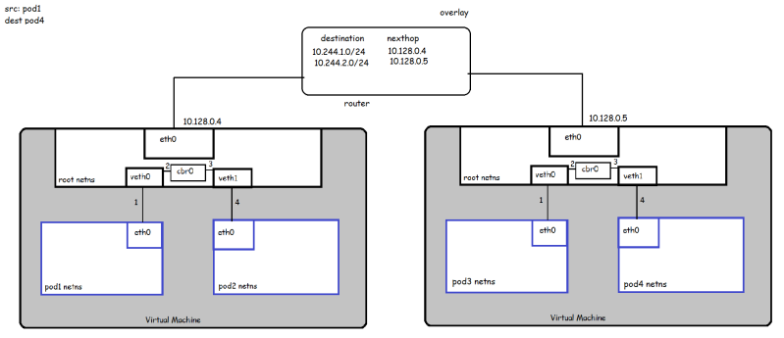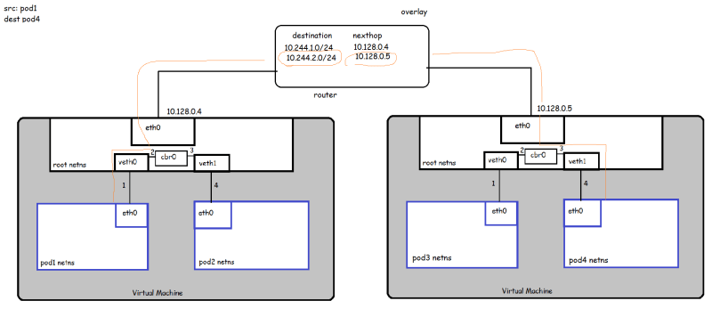

The **Address Resolution Protocol** (**ARP**) is a [communication protocol](https://en.wikipedia.org/wiki/Communication_protocol) used for discovering the [link layer](https://en.wikipedia.org/wiki/Link_layer) address, such as a [MAC address](https://en.wikipedia.org/wiki/MAC_address), associated with a given [internet layer](https://en.wikipedia.org/wiki/Internet_layer) address, typically an [IPv4 address](https://en.wikipedia.org/wiki/IPv4_address). This mapping is a critical function in the [Internet protocol suite](https://en.wikipedia.org/wiki/Internet_protocol_suite).

Here, Pod1 want to communicate to Pod4. First package will table within node by container bridge, if no response found it would be forwarded to default route.